SIMATS ENGINEERING (SAVEETHA SCHOOL OF ENGINEERING) Department of Computer Science and Engineering
ASSESSMENT TOOL 2 – CASE STUDY
Course Code: | CSA06 | Course Title: | Design and Analysis of Algorithms
CO Assessed: | CO3: Articulation (BL4, BL5) | Assessment: | Assessment Tool 2 – Case Study
Weightage: | 20% of CIA | Total Marks: | 100
CO3 Statement: | Design Divide and Conquer algorithms for Merge Sort, Quick Sort, Binary Search and Matrix Multiplication
Student Name: | R.NANDHINI | Reg. No.: | 192524355
Section / Batch: | 2025 | Date:

Instructions to Students
• Answer the following question. Total Marks: 100.
• Carefully analyze the given case study questions.
• Explain in detail with sample code if needed.
• Clearly identify all key issues, provide an in-depth analysis, and propose innovative, feasible solutions with strong justification.

Question Type | Focus Area | Questions
Case Study | Focus on Design Divide and Conquer algorithms: Merge Sort, Quick Sort, Binary Search and Matrix Multiplication | Q1

ANSWER:
- The system is used to sort player scores quickly for displaying a real-time leaderboard.
- Quick Sort is applied to arrange the scores in ascending or descending order.
- Quick Sort follows the Divide and Conquer technique.
- An element is selected as a pivot, and the remaining elements are divided based on the pivot.
- Elements smaller than the pivot are placed on the left, while larger elements are placed on the right.
- The same process is recursively repeated until the complete array is sorted.
- A poor pivot selection can create unbalanced partitions and cause worst-case O(n²) time complexity.
- With a good pivot, Quick Sort provides an average time complexity of O(n log n).
- Randomized pivot selection can reduce the chance of consistently getting poor partitions.
- The given example sorts 45, 12, 78, 23, 9, 56 into [9, 12, 23, 45, 56, 78], making it suitable for fast leaderboard updates.

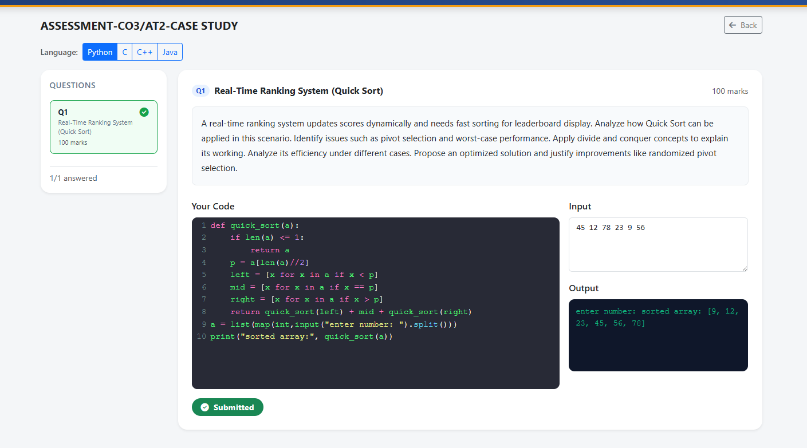
SECTION A – CASE STUDY
Code of Conduct
I __________________________ (Name / Reg No) certify that this submission is my original work and that I have adhered to the guidelines specified for this assessment. I understand that any violation of academic integrity rules will result in disciplinary action.
Signature of the Student: _________________________

RUBRICS FOR CALCULATION
Case Study
Criteria | Weightage | Level 4 –  Exemplary | Level 3 –  Proficient | Level 2 –  Developing | Level 1 –  Beginning
Understanding of Case | 25% | Thorough  understanding; clearly  identifies all  key issues | Good  understanding with most  issues  identified | Basic  understanding; some issues  missed | Poor  understanding; problem not  identified  correctly
Application of Concepts | 25% | Effectively  applies relevant concepts to  analyze the case deeply | Applies  appropriate  concepts with minor gaps | Limited  application of concepts | Fails to apply relevant  concepts
Analysis | 20% | In-depth  analysis with  strong  reasoning and insights | Good analysis with logical  reasoning | Basic analysis with limited  depth | Weak or no  analysis; lacks reasoning
Solution  Design | 20% | Innovative,  feasible  solutions with strong  justification | Logical  solutions with adequate  justification | Basic solutions with weak  justification | Incorrect or no solution  provided
Clarity | 10% | Clear, well  structured, and easy to  understand | Organized and understandable presentation | Limited clarity and structure | Poor clarity;  difficult to  understand

Marks Evaluation:
Criteria | Wt. | Level 4 –  Exemplary | Level 3 –  Proficient | Level 2 –  Developing | Level 1 –  Beginning
Understanding of Case | 25%
Application of Concepts | 25%
Analysis | 20%
Solution Design | 20%
Clarity | 10%
Total Marks (100):

Faculty In-charge | Course Coordinator | Head of Department
Name: | Name: | Name:
Signature: _______________ | Signature: _______________ | Signature: _______________
Date: ___________________ | Date: ___________________ | Date: ___________________

